RAPTOR TASK (DECISION MAKING)

SUBMITTED BY: LAIBA MUDASSAR
ROLL NO: SP26-BCS-021
SUBMITTED TO: MAM MARIAM
COMSATS UNIVERSITY ISLAMABAD

LAB TASK 1: (FIVE DAY DISCOUNT SALE)
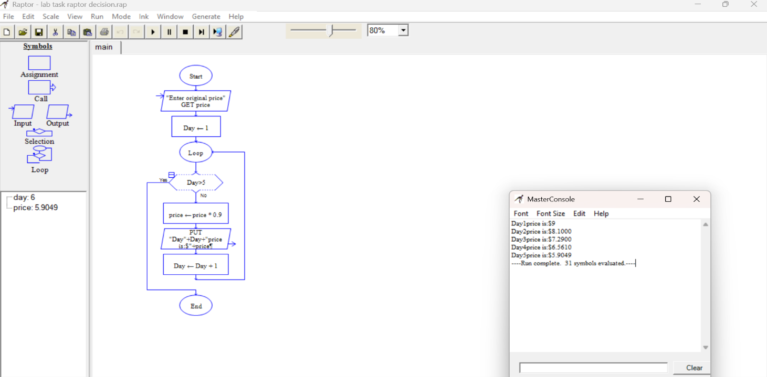

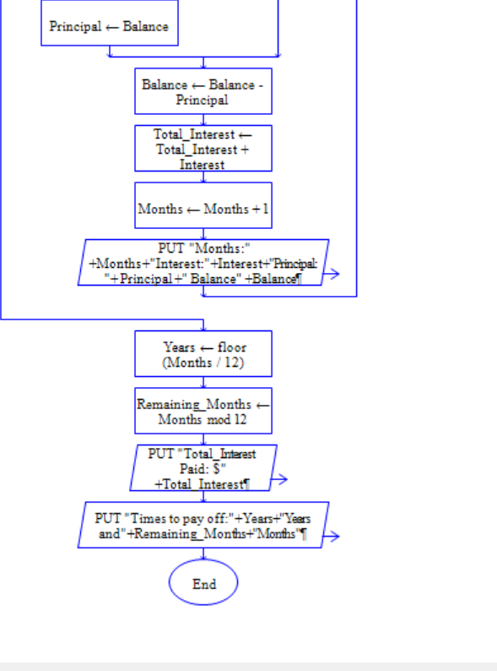
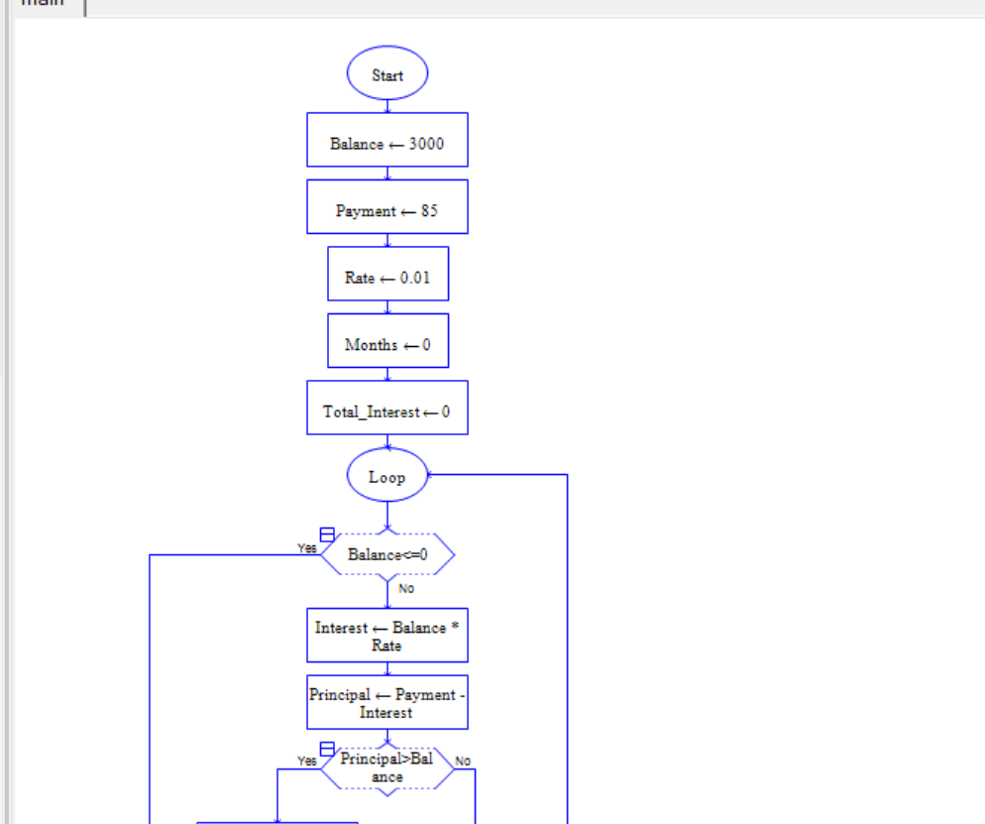
Lab task 2: LOAN PAYMENT SYSTEM
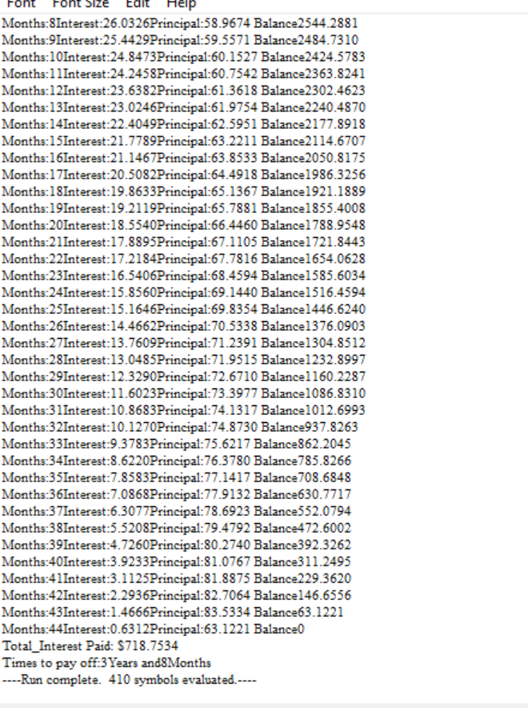
OUTPUT CONSOLE:

